Project Design Phase-II

Data Flow Diagram & User Stories

|  |  |
| --- | --- |
| Date | 03 October 2022 |
| Team ID | PNT2022TMID33663 |
| Project Name | Project - IOT Based smart Crop Protection System for Agriculture |
| Maximum Marks | 4 Marks |

**Data Flow Diagrams:**

**Flow**

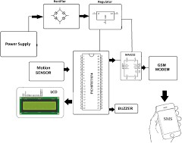

**Example:DFD level 0**

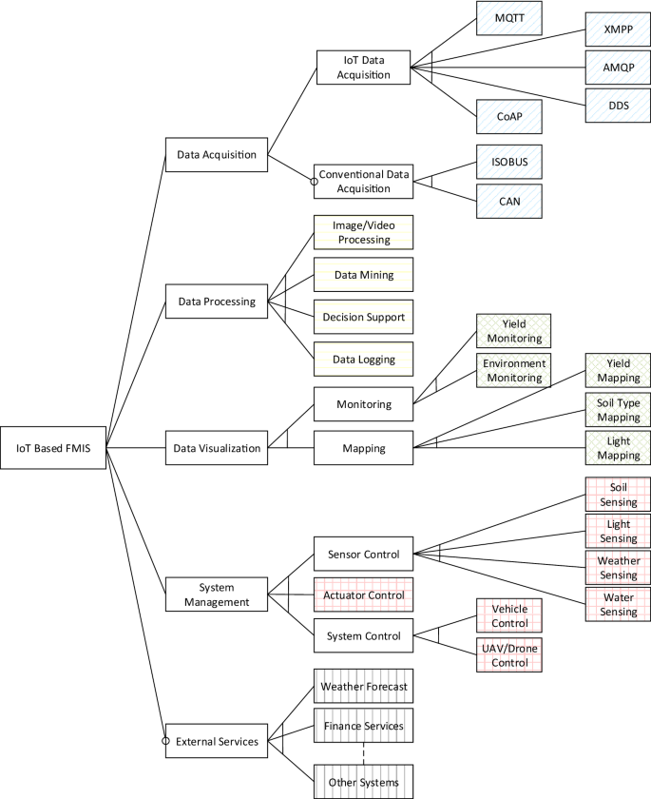

**User stories**

|  |  |  |  |  |  |  |
| --- | --- | --- | --- | --- | --- | --- |
| **User Type** | **Functional Requireme nt (Epic)** | **User Story Number** | **User Story / Task** | **Acceptance criteria** | **Priority** | **Release** |
| Customer (Mobile user) | Registration | USN-1 | As a user, I can register for the application by entering my email, password, and  confirming my password. | I can access my account / dashboard | High | Sprint-1 |
|  |  | USN-2 | As a user, I will receive confirmation email once I have registered for the application | I can receive confirmation email & click confirm | High | Sprint-1 |
|  |  | USN-3 | As a user, I can register for the application through Facebook | I can register & access the  dashboard with Facebook Login | Low | Sprint-2 |
|  |  | USN-4 | As a user, I can register for  the application through Gmail |  | Medium | Sprint-1 |
|  | Login | USN-5 | As a user, I can log into the application by entering email & password |  | High | Sprint-1 |
|  | Dashboard | USN-6 | As a user, I can view my status of my application and  the current progress. | I can see the record of my application. | Medium | Sprint-1 |
| Customer (Web user) | Application | USN-7 | As a user, I can monitor the field using the web itself. | I can aware of whether an animal attack is happening. | High | Sprint-2 |
| Customer Care  Executive | Maintenance | USN-8 | As a user, I can get executive support for my problems in  application. | I can rectify the problem created in  application | Medium | Sprint-2 |

|  |  |  |  |  |  |  |
| --- | --- | --- | --- | --- | --- | --- |
| **User Type** | **Functional Requirement (Epic)** | **User Story**  **Number** | **User Story / Task** | **Acceptance criteria** | **Priority** | **Release** |
| Administratar | Control of activity | USN-9 | As a user, I can request the control to use features in application for better functionality. | I can control the application with admin permission | High | Sprint-1 |
| Home user | Monitor from  home | USN-10 | As a user, I can monitor the  field from home itself | I can monitor the  animal attack | High | Sprint-2 |